**AIM: PROGRAMS BASED ON INTERFACING LED‘S, POTENTIOMETER, PHOTO RESISTOR WITH ARDUINO PROGRAMS USING PWM PINS OF ARDUINO, PROGRAMS USING SERIAL MONITOR OF ARDUINO**

**THEORY:**

LDR (Light Dependent Resistor):

An LDR is a component that has a (variable) resistance that changes with the light intensity that falls upon it. This allows them to be used in light sensing circuits. Light Dependent Resistors (LDR) are also called photoresistors. They are made of high resistance semiconductor material. When light hits the device, the photons give electrons energy. This makes them jump into the conductive band and thereby conduct electricity. Light dependent resistors, LDRs or photoresistors are often used in circuits where it is necessary to detect the presence or the level of light. They can be described by a variety of names from light dependent resistor, LDR, photoresistor, or even photo cell, photocell or photoconductor. A Light Sensor is something that a robot can use to detect the current ambient lightlevel - i.e. how bright/dark it is. There are a range of different types of light sensors, including 'Photoresistors', 'Photodiodes', and 'Phototransistors'.

**CIRCUIT DIAGRAM:**

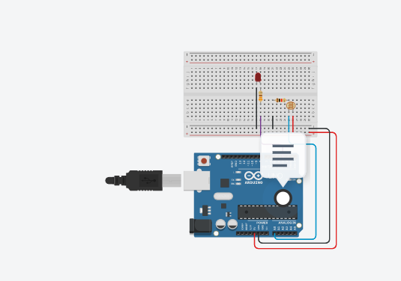

**SOURCE CODE:**

const int LED = 3;

const int LDR = A0;

int timer = 50;

void setup()

{

pinMode(LED, OUTPUT);

pinMode(LDR, INPUT);

Serial.begin(9600);

}

void loop()

{

int brightness = 0;

int sensorval = analogRead(LED);

float voltage = sensorval * (5.0/1024.0);

brightness = analogRead(LDR);

if(brightness<=110){

digitalWrite(LED, LOW);

}

else{

analogWrite(LED, map(brightness, 110, 540, 0 , 255));

}

delay(timer);

Serial.println(brightness);

Serial.println(voltage);

}

**OUTPUT:**

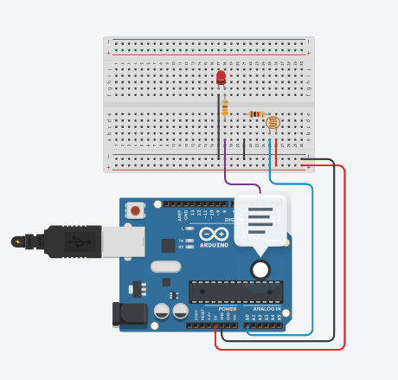

**CONCLUSION:**

From this practical, I have learned and implemented photo resistor with arduino.